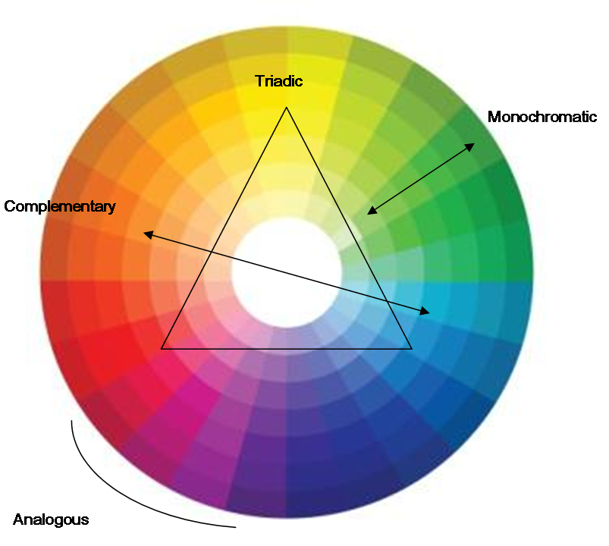

- Monochromatic – shades of the same colour

- Analogous – 2-3 colours next to each other on the colour wheel

- Complementary – colours opposite on the colour wheel

- Triadic – 2-3 colours equally spaced on the colour wheel

