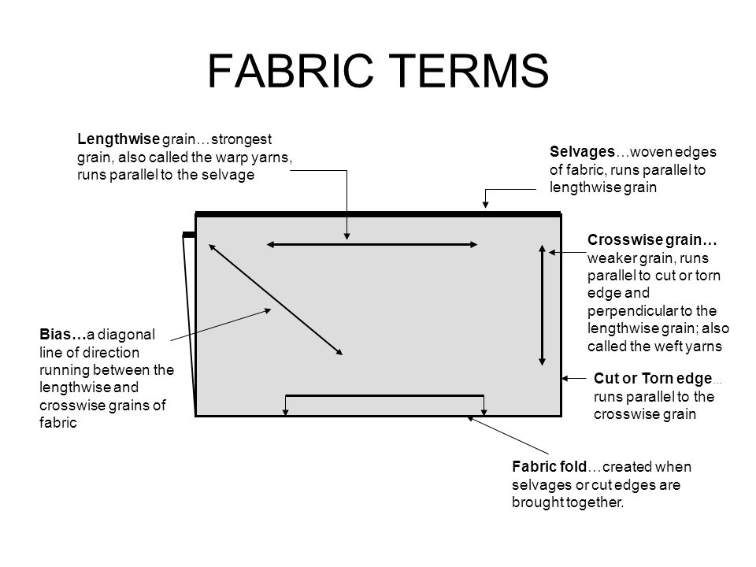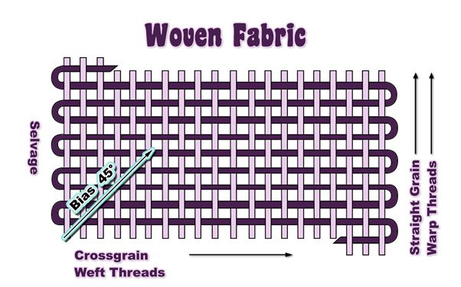
Length wise Grain
Filler Threads
- The two “finished” edge of material that is created on the loom, Runs the length of the material
__________________________________________
  - The threads that follow in the same direction as the length of the material are called
__________________________________
  - This grain is called the ____________________________ and should almost always run up and down the body. It has the _____________________ stretch.
  - When you fold the two Selvages together the fold is called a _______________________ and it will look _____________________ and _____________________
  - It has the ____________________ ________________
Most pattern layouts will call for this type of fold

- The other two ends that was cut at the store, runs the width of the material
___________________________________________
  - The threads that follow in the same direction as the width of the material are called
_________________________________________
  - This grain is called the ____________________________ and should almost always run around the body.
  - It has ____________________ stretch.
  - When you fold the two Cut end together the fold is called a ______________________ and it will look _________________________ and _________________________
- The diagonal of the woven fabric is called the
________________________________________
  - This direction always has the most ________________________
- A _____________________ fold is used most often
  - You fold one _________________________ to the other ____________________________
- Sometimes we need two folded edges, so we can fold the two selvages so they meet in the center, creating two lengthwise folds. This is called a __________________________ fold.

- If the fabric is folded only part way across to allow some pieces to be cut using only a single piece of material. This is called a _________________________ fold

