How to Hand Sew the Slip Stitch
- Choose a color of thread that matches  - Take about an arm’s length of thread  - Thread through the eye of the needle  - Only use a single thread and tie a knot | 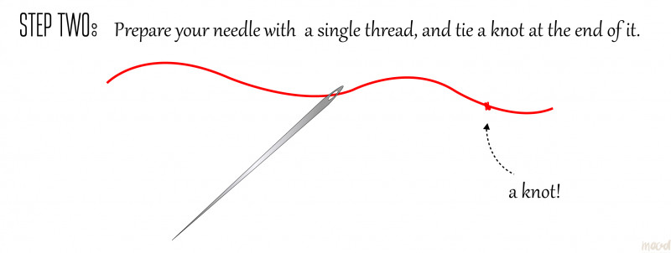
- Insert the needle through the fold of the fabric  - Pull the thread through, until the knot is hidden inside the fold and the thread is taut | 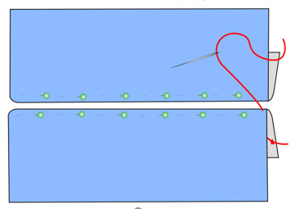
- Stitch Along the Fold. ... | 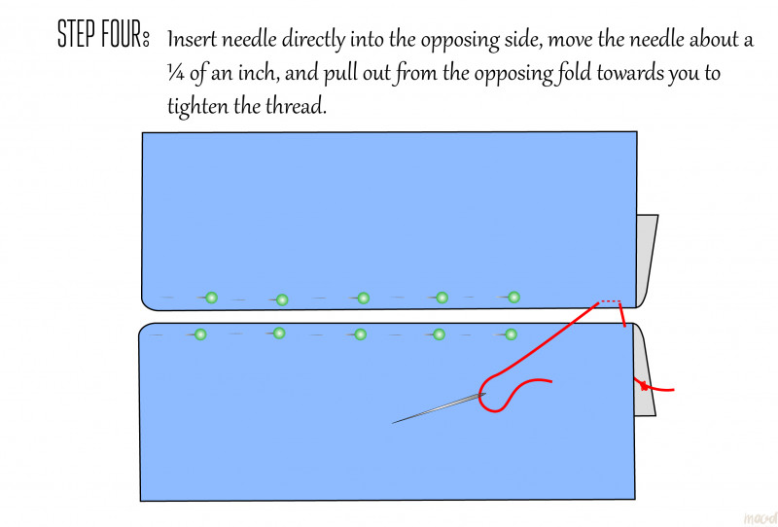
- Go to the opposite side and stitch through the fold  - Keep Stitching going back and forth through the opposite fold lines | 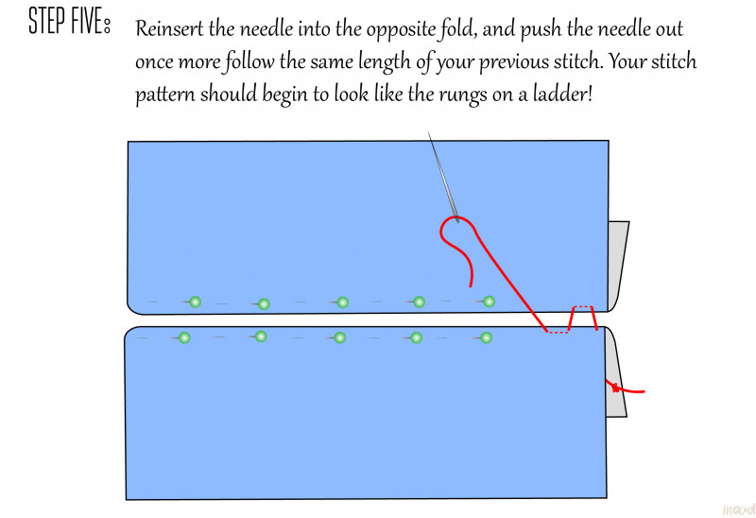  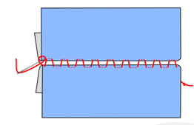
- When finished tie off the thread | 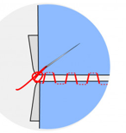
- Push the needle through the last stitch through the pillow all the way and cut off the thread | 