Brand | Number | Detail I like | Picture
Vogue | 8817 | Fitted, color block, different length and sleeve length | 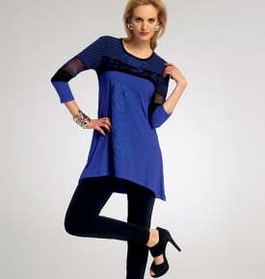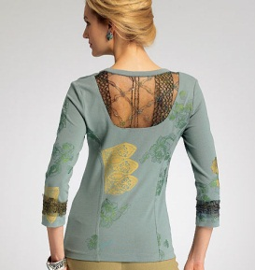
Vogue | 8636 | Simple, raglan sleeve, detail at neck and sleeve | 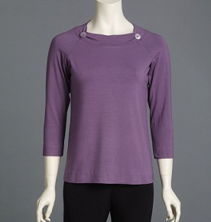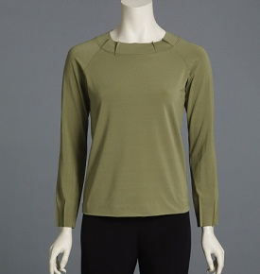
Vogue | 8792 | Dolman sleeve, extra detail in body, can color block, fitted dart at bust | 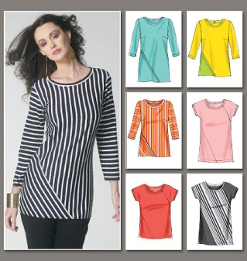
Butterick | 6058 | Cowl neck, can color block, different length | 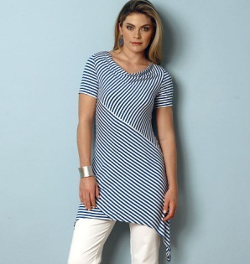
Butterick | 5354 | Detail at neck, sleeveless, short, ¾ or long | 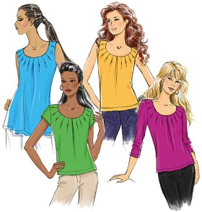
Butterick | 5495 | Nice front detail by bust, dolman sleeve, sleeveless, short or long, different finished lengths | 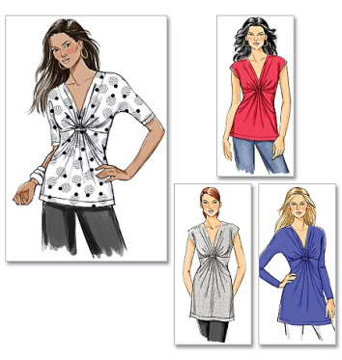
Butterick | 5356 | Variable style with neck, sleeve and length | 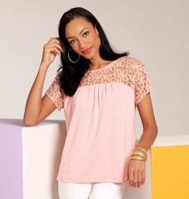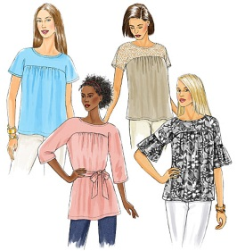
Butterick | 5753 | Simple, dolman sleeve, color block, fitted at waist | 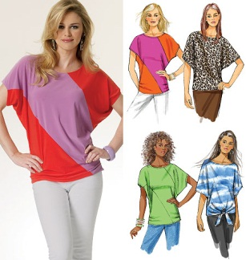
McCalls | 7019 | Side and front detail
McCalls | 6992 | A fitted type of sweatshirt, raglan sleeve, lots of options with design details | 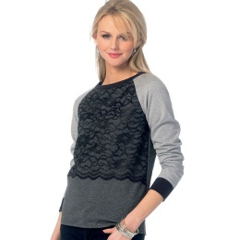
McCalls | 6964 | Basic Tshirt | 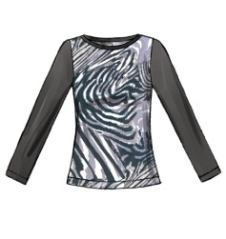
McCalls | 6963 | Basic tshirt with cowl neck
McCalls | 6797 | Different sleeve openings, asymmetrical hem, loose at bust line and tapers to fitted at hips | 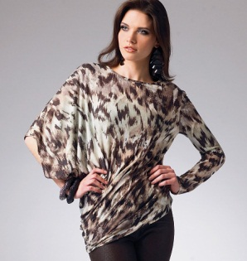
McCalls | 6566 | Basic Tshirt, can color block, dolman sleeve, can have patch pocket | 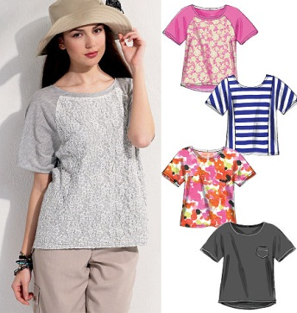
McCalls | 6794 | Fitted at waist with tie sash at back, v neck or large round, dolman sleeves, back can be longer than front | 