Winter
Winter types should wear colors that are sharp and clear. White, black, navy blue, red and shocking pink all go well with winter complexions. For lighter colors, wear icy tones rather than pastels. Avoid subdued tones like beige, orange and gold.
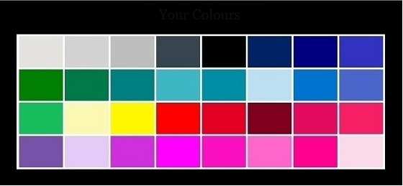
Extra tips:
Use a maximum of 3 colors for your outfit.
Dare to wear contrasting colors like black and white. You are the only type that looks good in black and pure white, use these colors!
For jewelry, silver is your color. Don’t exaggerate with jewelry and accessories.
Summer
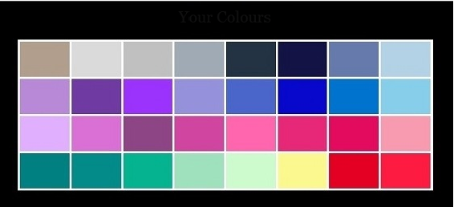
Summer types should choose pastels and soft neutrals with rose and blue undertones. Lavender, taupe, powder pink and powder blue suit summer types very well while black and orange do not.
Extra tips:
Wear a lot of jewelry (silver), try different accessories.
For a relaxed and friendly look, choose pastels.
Autumn
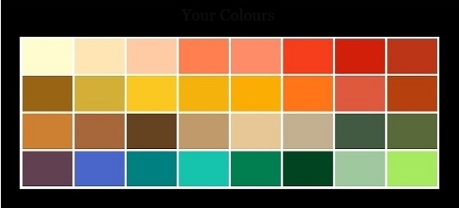
Fall types should select colors with golden undertones, like camel, beige, orange, gold and dark brown. Avoid colors with blue tones, like navy.
Extra tips:
Use many colors, experiment with jewelry, be daring! The best color for your jewelry is gold.
To convey creativity, mix colors. Make sure to combine colors that match and complement each other well, such as green and red.
Spring
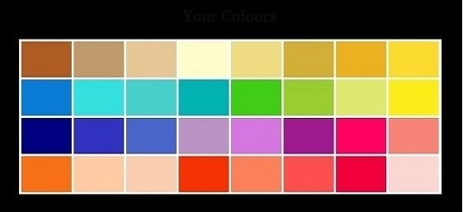
Spring types can wear warm colors like camel, peach, golden-yellow and golden brown. Avoid dark, dull colors. Do not wear black and white.
Extra tips:
Don’t exaggerate with jewelry, wear gold (colors).
Light colors look best on you.
Wear reds for all of your personality traits. Blue-red conveys assertiveness. An orange-red would be worn by someone who is lively.

